## Final Project

## MongoDB Database

## Matt Gruber

### Now URL: https://triviaapp-vvgrhwdfmy.now.sh

### Overview

### Spaced Repetition is a learning technique that prompts someone with information at increasing intervals of time to reinforce learning. I plan to use a node app and chrome push notifications while utilizing this technique to help people learn random trivia facts.

### The user can create, read, update, and delete a user and reminder. These routes have been created and are now accessible. I tested these routes with a series of curl calls in testRoutes.txt.

### CREATE

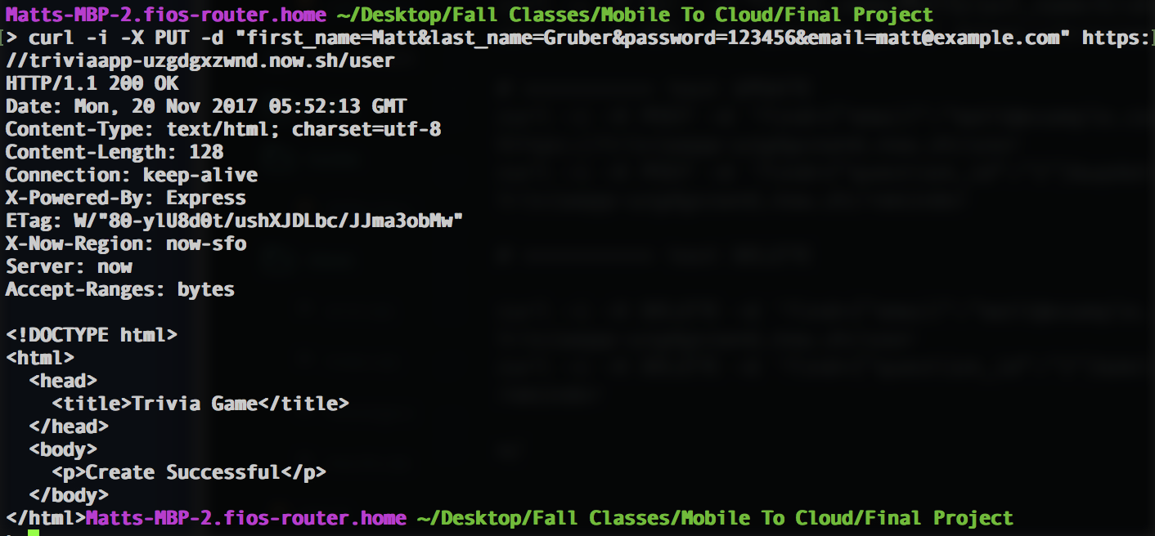

Creating User

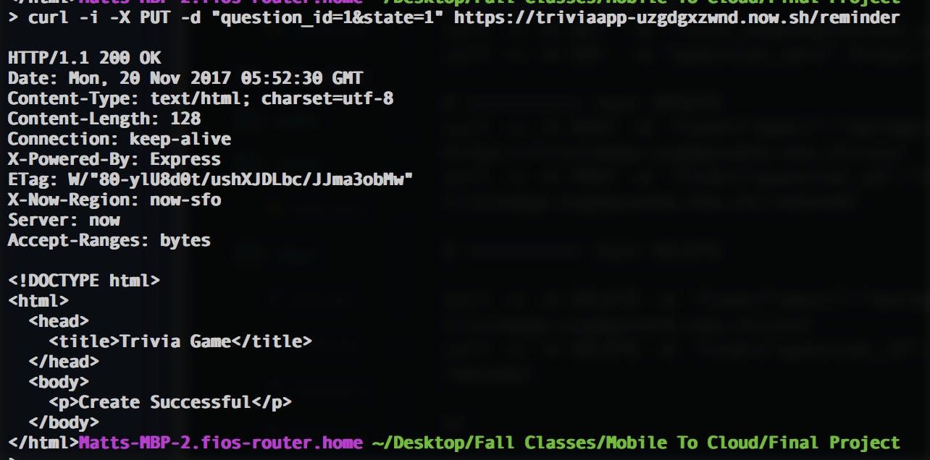

Creating Reminder

### READ

### 

### Reading User

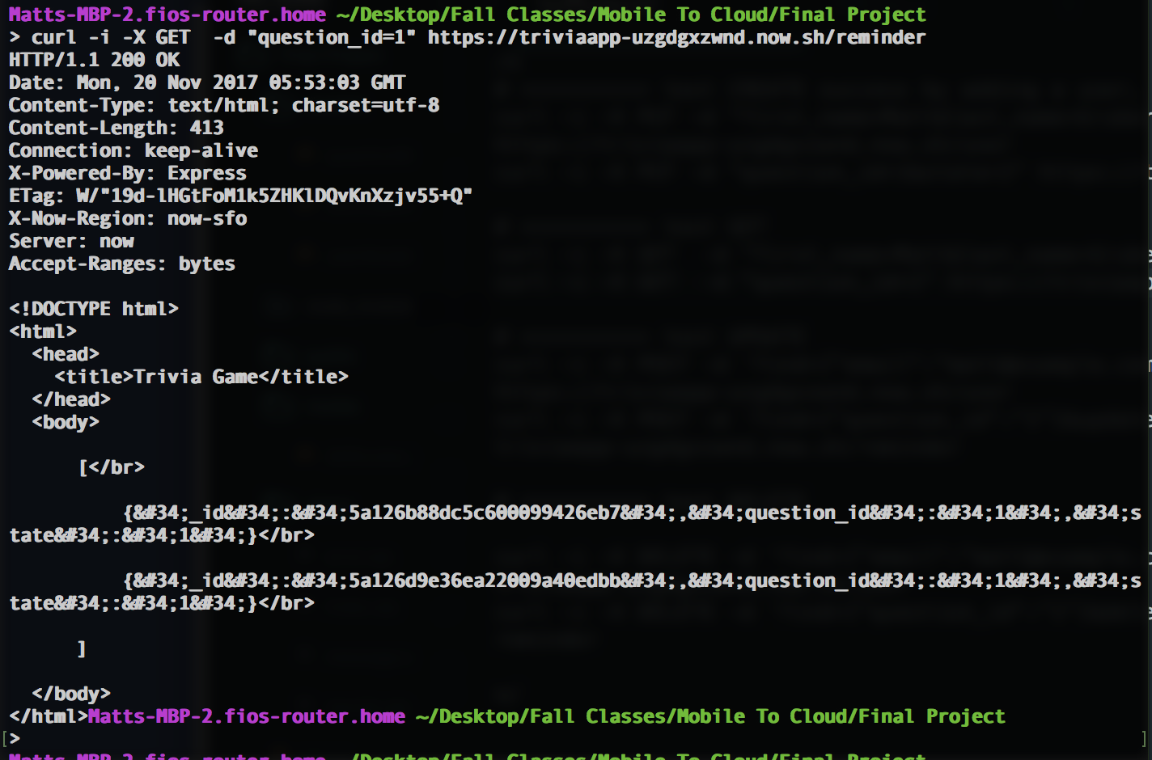

Reading Reminder

### UPDATE

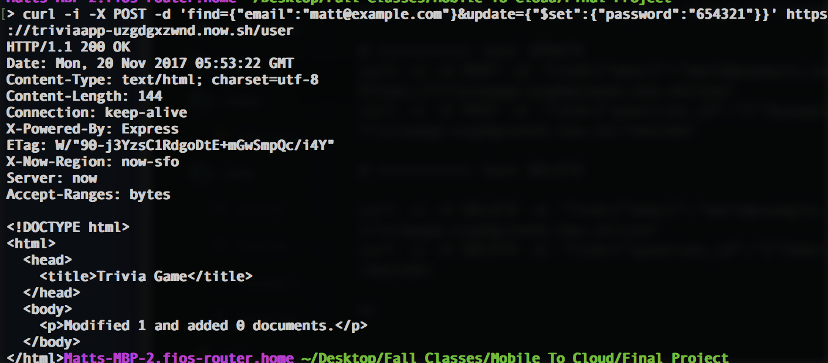

Updating User

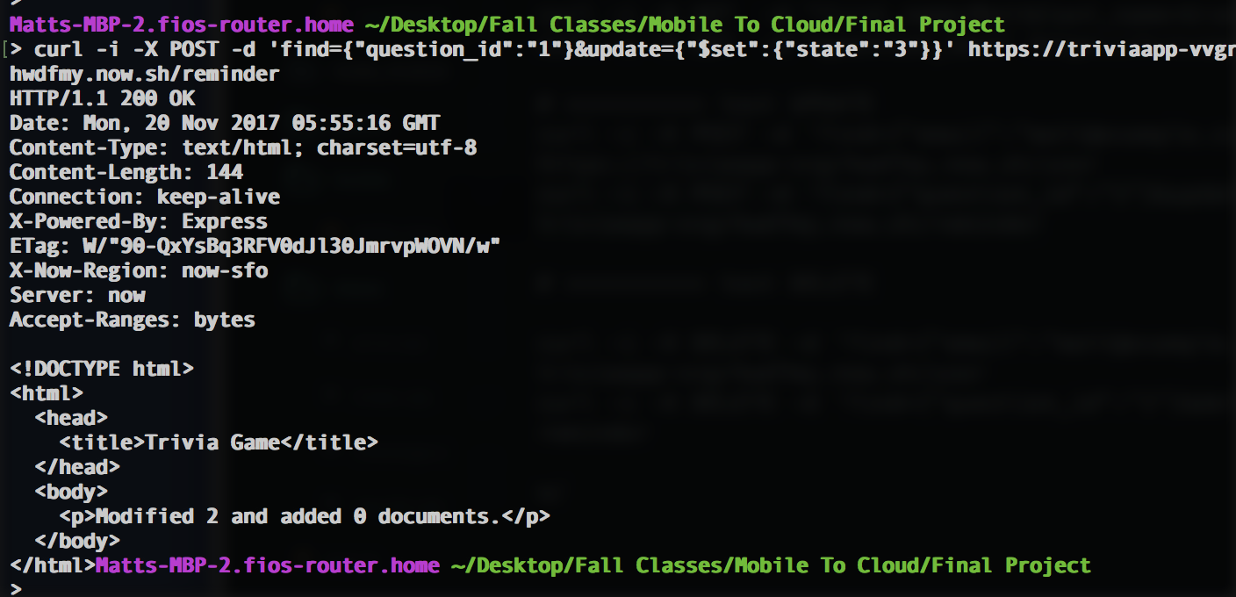

Updating Reminder

### DELETE

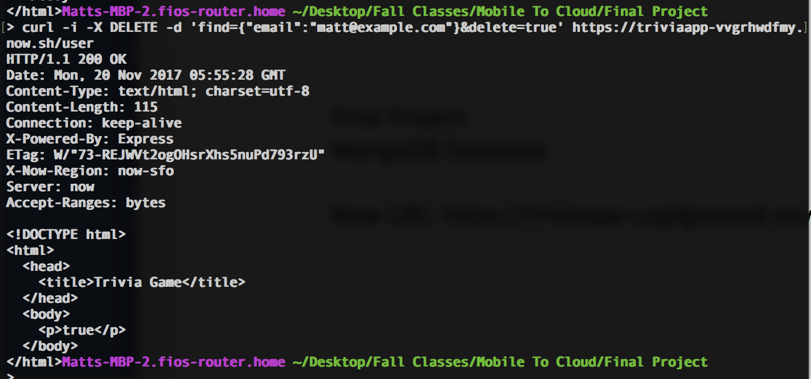

Deleting User

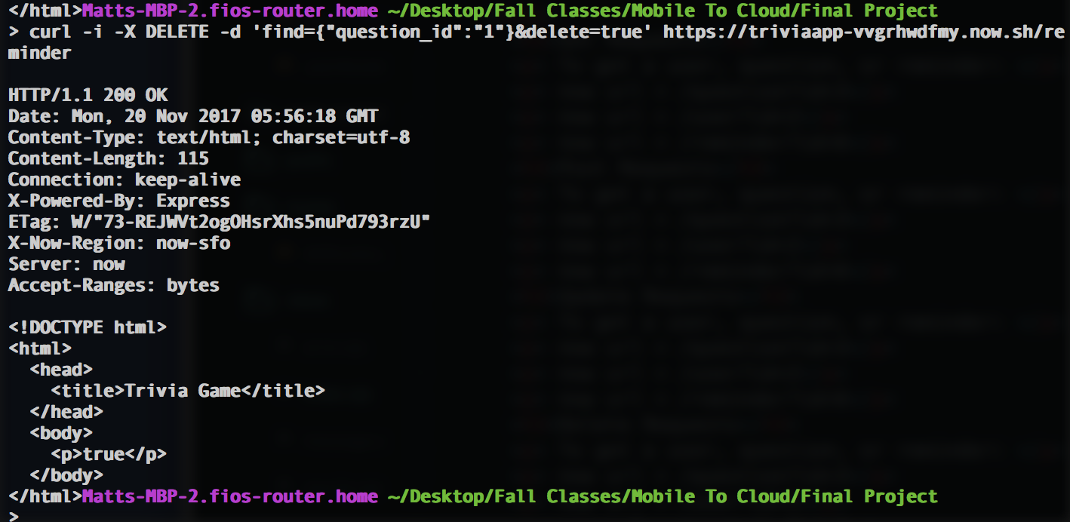

Deleting Reminder